Very handy and Very Important method

.split ( )

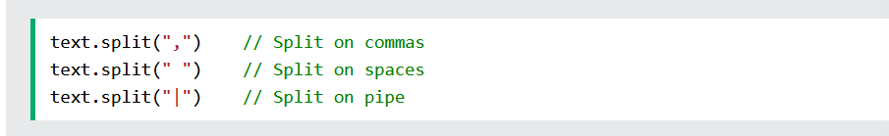

See below

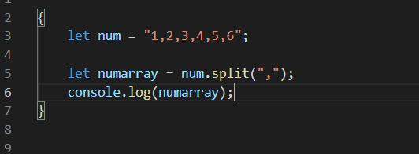



But the numbers still remains string type not Number type

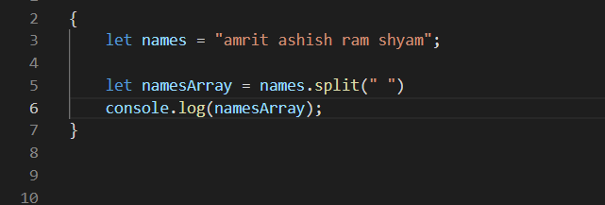

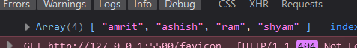

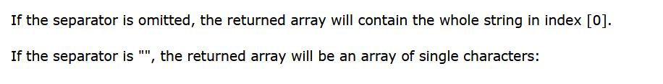

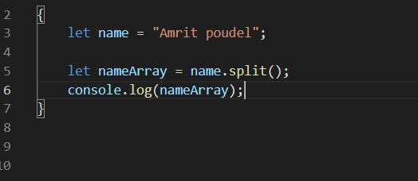

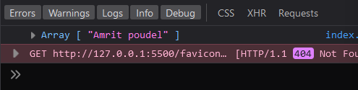

See the whole string gets inside o’th index of the array

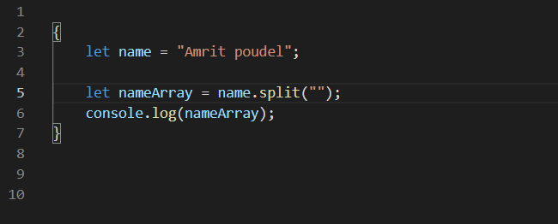

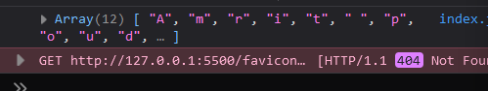

passing .split(“”) will give us array where each letter is the item of that array